**Field Flume Wax Lake Delta**

Purposes of project:

* Derive functional form of particle interception by vegetation
* Determine how relationship changes when biofilm is present
* Test h0 that interception plays a significant role in delta landform evolution
* Educate the next generation of students about fine sediment transport processes and fluid dynamics
* Increase public understanding of land-building processes in coastal ecosystems

In situ flumes, Wax Lake Delta, LA:

* Upstream region: diverging flow & emerging clonal giants (Phragnites australis, Zizaniopsis milincen, Typha spp., Colocassia esculenta, Polygonum punctatum) **w/out extensive biofilm development**
* Downstream region: sheet flow & water lotus (Nelumbo lutea) **extensively coated w/ biofilm**

Specifications from proposal:

* 10 m long x 1 m wide constructed from 0.2 cm thick PVC sheets
* Sunk into ground around intact vegetation, sealed at edges, held in place by external steel fence posts
* Aligned parallel to flow & opened at both ends
* Removable extensions angled outward at 15o appended to upstream portion, enabling experiments to be run under ambient or enhanced flow
* Contain ADV, LISST-FLOC, and two sampling manifolds placed upstream and downstream in flume
* Sampling intake ports set at multiple water depths & pumped simultaneously via peristaltic pumps
* ADCP at outlet of flume to compute precise flow rates
* Sediment traps w/in canopy & on select vegetation stems
* Settling velocity distributions w/in column as in Larsen et al. 2009a

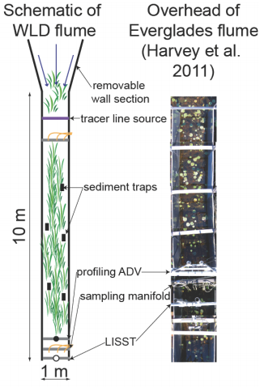

**FLOW ENHANCEMENT:**

Gibbins et al., 2007:

* In situ flume in gravel bed river; focused on patches of bed sediment
* Measured hydraulic conditions and rates of bedload transport
* Max u was 2.14 m s-1
* Designed to be portable with open bottom to isolate patch of stream bed
* Hinged doors at upstream end:
  + 2 positions
    - Normal position: parallel to sides of flume
    - Open position: funneled water from 2-m wide section into flume, increasing discharge and altering hydraulic conditions
  + Perspex sheet slid vertically to further increase velocity and shear stress
    - Slid to fixed position leaving 15 cm gap between bottom of Perspex and stream bed
    - Once positioned at start of experiment was not moved
    - Perspex effects calculated using vertical velocity profile gradient for shear stress
* At 0.4d velocity before manipulations was .53 m/s and after was .96 m/s
* At 0.2d velocity before manipulations was .39 m/s and after was .86 m/s

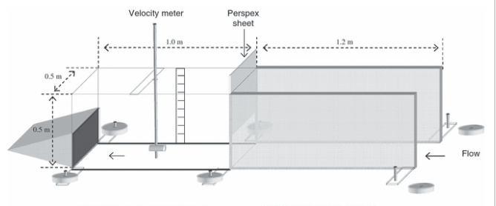

Vericat, 2008:

* Same flume as Gibbins with thinner walls (1 cm) & light, smooth material (Perspex) to limit flow disturbance

Huang, 2008:

* Everglades: wetland, so maybe closer to what we want
* 4.8 m long and 1 m wide
* Open to ground surface & at upstream end; long axis parallel to ambient flow
* 0.2 cm thick PVC sheets framed in steel posts and driven 0.1 m into peat
* Boardwalks along one side of each flume and between two flumes for instrumentation space and access for water sampling
* Steady flow maintained under forced gradient conditions
* Radial flow w/in 0.5 m of withdrawal wells but uniform and parallel w/ flume walls further upstream

Harvey, 2011:

* Everglades
* Relatively large field flume (7.3 m long by 1 m wide)
* 0.2 cm thick PVC sheets inserted 0.1 m into peat; held in place by external steel fence posts driven 0.75 m into peat
* Both ends open
* Removable wall downstream w/ centrifugal pumps (withdraw at 0.67 m3 min-1)

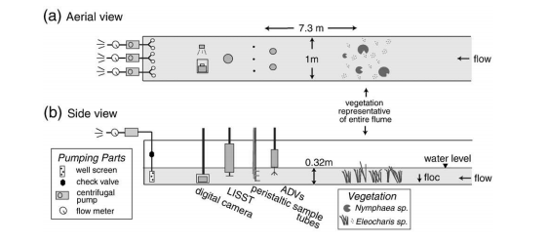

* Flow laminar in first two steps (1.7 & 3.2 cm/s), laminar in 3 & 4 (5.3 & 5.7 cm/s), vortex shedding at last steps

OTHER IDEAS:

* Some sort of removable grid or funnel insert at start of flume to concentrate flow
* Funnel idea would be similar to pumps but opposite; not sure how that translates to the radial effects downstream
  + Three funnels spaced equally laterally and fed through a whole in a Perspex or PVC sheet.

**INSERT FIGURES**

**PARTICLE CAPTURE:**

General ideas:

* Somehow need to capture horizontal portion captured on stems
* Will be difficult b/c have to deal w/ blocking flow and biofilm effects
* Flexible rods (straws? b/c vegetation in everglades was like straws) coated in a sticky substance, synthetic biofilm, or actual biofilm
* Grid mesh so flow can go through but sediment trapped
* Cylinder with front open for sediment capture, similar to BSNE samplers in desert from Fryrear, 1986/ Field et al., 2012
* Cut and wipe and desiccate stems similar to in Everglades

Issues are that the stems are probably ‘capturing’ different volumes and size distributions of particles in different portions of the flow

* How to compare ‘stickiness’
* How to remove particles from the sticky
* Does organic vs. non-organic matter? or what are we considering sediment?

Gacia, 1999:

* Seagrass beds as sinks for fine particles
* Used sediment traps
* 20.5 mL cylindrical glass centrifugation tubes with AR of 5 (16 mm diameter)
* Attached by groups of 5-30 cm long stainless bars & mounted w/ separation of 4 cm from each other
* Triplicate sediment traps for estimates of total depositional fluxes fixed at 20 cmab

Palmer, 2004:

* Cylindrical rods of Delrin varying diameter
* Coated in 2-3 mm thick clear silicone grease (ChemPlex silicone compound 710 by NFO Technologies) & excess wiped off
* Measure “capture” w/ camera & counting 🡪 need a better method for volumetric/non-particulate capture
* **Could grow biofilm directly on straws 🡪 release fluorescent particles so get volume of particles captured with the fluorometer 🡪 or could subtract out mass before particle release**

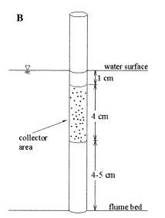

**Summary/Suggestions:**

Overall flume design:

* Keep original design from proposal
* Make two ‘permanent’ flumes with a walkway/boardwalk to allow easy access of the equipment

Flow Enhancement:

* Either pumps circa Harvey et al. or the ‘v’ funnel and one of the insertable ideas in the last bullet of that section

Particle Capture:

* Sediment plates for settling portion
* Palmer et al. style rods using fluorescent particles to get at the mass captured
  + Could even compare what is caught on the synthetic biofilm rods to that caught on the actual stems in flow if using fluorescent particles